My Target: ____ / or ______ % Complete on the day of the test

🖒 🖓 (Circle when your test is handed back)



Year 8 HASS- Geography Name:

Task 2: Geomorphic Hazards Information Brochure (%15)

**Mark:­­__________/60**

**Summary of task:**

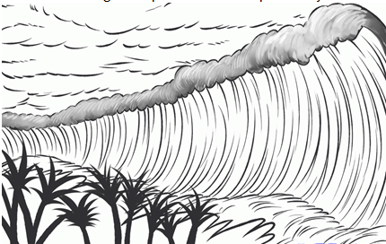Your task is to develop a brochure that promotes community awareness about a chosen geomorphic hazard, relating to the geology of the surface of the earth. You will explore the geomorphic hazard in detail in class and then will have time in class to research the geomorphic hazard and produce your information brochure.

**This assessment is in two parts:**

[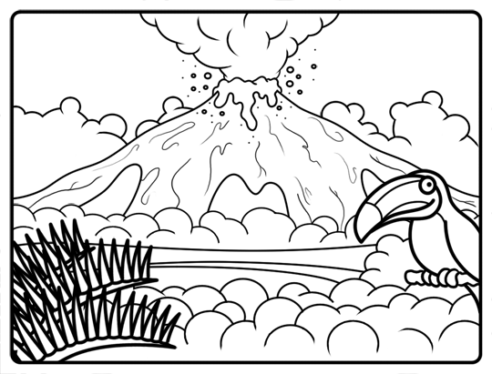](http://www.google.com.au/url?sa=i&rct=j&q=&esrc=s&source=images&cd=&cad=rja&uact=8&ved=0ahUKEwjeqN7F76jVAhWHhFQKHed4B3kQjRwIBw&url=http://www.how-to-draw-cartoons-online.com/cartoon-volcano.html&psig=AFQjCNE-0YLP9ltE8-5iP401ijI5dGD_Tw&ust=1501224409040034)

**Part A: Inquiry Booklet**

You are to conduct research into your chosen geomorphic hazard and complete the following tasks;

* Write focus questions
* Make notes using the note taking sheet provided (Your notes can include notes from in class lesson on the chosen geomorphic hazard)
* Compile a bibliography using the framework provided

**Part B: Information Brochure**

Your information brochure must address the following;

* The geographical processes involved
* The nature of the geomorphic hazard (features or characteristics)
* The environmental, economic and social impacts of the geomorphic hazard
* The responsibilities of the various levels of government in respect to the geomorphic hazard.
* The community groups involved in responding to the geomorphic hazard
* The strategies individuals can use to protect themselves and their property.

**INQUIRY BOOKLET AND BROCHURE DUE: WEEK 7, TERM 3**

**Part A: Inquiry Booklet**

**Section 1: Planning the inquiry**

*Complete the spaces below in order to successfully plan your inquiry.*

1. What geomorphic hazard is my class focusing on?

1. What exactly am I being asked to do? Highlight the key words from the task summary.
2. Use the space below to brainstorm what you already know about the topic.

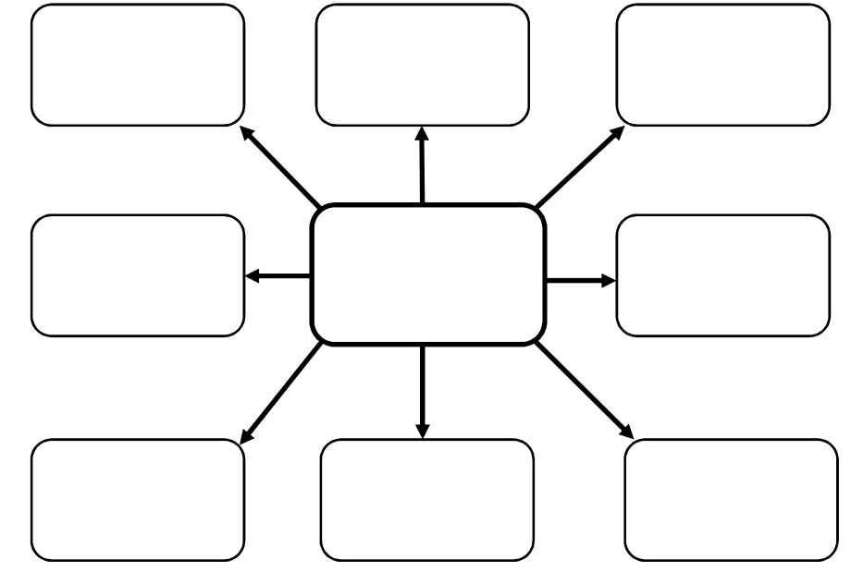

Teacher to tick when completed

1. What do I already know about the topic? What do I need to know? (What did I learn to be completed at the end)

|  |  |  |
| --- | --- | --- |
| *What I* **K***now* | *Want to Learn* | *What I Learnt* |
|  |  |  |

Teacher to tick when completed

**NOTE-TAKING SHEET**

**Focus Question 1**

|  |
| --- |
|  |

**Extract keywords from information source**

|  |
| --- |
|  |

**Construct full sentences from keywords**

|  |
| --- |
|  |
|  |
|  |
|  |
|  |
|  |
|  |
|  |
|  |
|  |
|  |
|  |
|  |
|  |

Teacher to tick when completed

**NOTE-TAKING SHEET**

**Focus Question 2**

|  |
| --- |
|  |

**Extract keywords from information source**

|  |
| --- |
|  |

**Construct full sentences from keywords**

|  |
| --- |
|  |
|  |
|  |
|  |
|  |
|  |
|  |
|  |
|  |
|  |
|  |
|  |
|  |
|  |

Teacher to tick when completed

**NOTE-TAKING SHEET**

**Focus Question 3**

|  |
| --- |
|  |

**Extract keywords from information source**

|  |
| --- |
|  |

**Construct full sentences from keywords**

|  |
| --- |
|  |
|  |
|  |
|  |
|  |
|  |
|  |
|  |
|  |
|  |
|  |
|  |
|  |
|  |

Teacher to tick when completed

**NOTE-TAKING SHEET**

**Focus Question 4**

|  |
| --- |
|  |

**Extract keywords from information source**

|  |
| --- |
|  |

**Construct full sentences from keywords**

|  |
| --- |
|  |
|  |
|  |
|  |
|  |
|  |
|  |
|  |
|  |
|  |
|  |
|  |
|  |
|  |

Teacher to tick when completed

**NOTE-TAKING SHEET**

**Focus Question 5**

|  |
| --- |
|  |

**Extract keywords from information source**

|  |
| --- |
|  |

**Construct full sentences from keywords**

|  |
| --- |
|  |
|  |
|  |
|  |
|  |
|  |
|  |
|  |
|  |
|  |
|  |
|  |
|  |
|  |

Teacher to tick when completed

**List of resources used**

**The ethical recording and communicating of evidence:** List the bibliography information of all resources from which you have taken information. You are legally required to acknowledge the author or editor who wrote or compiled the information you have used for your assignment.

**Bibliography/reference list framework**

**Books**

|  |  |  |  |  |
| --- | --- | --- | --- | --- |
| **Author** | **Year** | **Title** | **Publisher** | **Place** |
|  |  |  |  |  |
|  |  |  |  |  |
|  |  |  |  |  |
|  |  |  |  |  |
| **More than one author** |  |  |  |  |
|  |  |  |  |  |

**Encyclopaedia or dictionary**

|  |  |  |  |  |  |  |  |
| --- | --- | --- | --- | --- | --- | --- | --- |
| **Author** | **Year** | **Title of article** | **Title of encyclopaedia** | **Volume** | **Publisher** | **Place** | **Page(s)** |
|  |  |  |  |  |  |  |  |
|  |  |  |  |  |  |  |  |

**Magazine articles**

|  |  |  |  |  |  |  |
| --- | --- | --- | --- | --- | --- | --- |
| **Author** | **Year** | **Title of article** | **Title of magazine** | **Volume** | **Number** | **Page(s)** |
|  |  |  |  |  |  |  |
|  |  |  |  |  |  |  |
|  |  |  |  |  |  |  |

**Newspaper article**

|  |  |  |  |  |  |
| --- | --- | --- | --- | --- | --- |
| **Author** | **Year** | **Title of article** | **Title of newspaper** | **Date** | **Page(s)** |
|  |  |  |  |  |  |
|  |  |  |  |  |  |
|  |  |  |  |  |  |

**Film or video**

|  |  |  |  |  |
| --- | --- | --- | --- | --- |
| **Title** | **Year** | **Format** | **Publisher** | **Place** |
|  |  |  |  |  |
|  |  |  |  |  |

**World wide web – document**

|  |  |  |  |  |
| --- | --- | --- | --- | --- |
| **Author** | **Year or last update** | **Title of website** | **Date retrieved** | **ULR (website address)** |
|  |  |  |  |  |
|  |  |  |  |  |
|  |  |  |  |  |
|  |  |  |  |  |
|  |  |  |  |  |

**World wide web – image**

|  |  |  |  |  |
| --- | --- | --- | --- | --- |
| **Title** | **Format** | **Year** | **Date retrieved** | **ULR (website address)** |
|  |  |  |  |  |
|  |  |  |  |  |
|  |  |  |  |  |

**Online encyclopaedia**

|  |  |  |  |  |
| --- | --- | --- | --- | --- |
| **Title of article** | **Year** | **Title of website** | **Date retrieved** | **ULR (website)** |
|  |  |  |  |  |
|  |  |  |  |  |
|  |  |  |  |  |

Name:____________________________ My Target:_______/60 or _______%

**Year 8- Geography- Title of task: Geomorphic Hazard information brochure (Inquiry Task)**

**DETAILED MARKING GUIDE/RUBRIC**

**PART A: INQUIRY BOOKLET (10%)**

|  |  |  |  |  |  |
| --- | --- | --- | --- | --- | --- |
|  |  |  |  | **4-3** | **2-0** |
| **Brainstorm**  **/4** |  |  |  | Presents a very detailed and comprehensive brainstorm which clearly outlines prior knowledge on the chosen geomorphic hazard. | Presents a brainstorm which lacks detail and shows limited prior knowledge on the chosen geomorphic hazard. |
|  |  |  | **7-8** | **4-6** | **0-3** |
| **KWL Chart**  **/8** |  |  | Presents a very detailed and comprehensive plan through the use of a KWL chart. Comprehensive detail is used in each section of the KWL chart, which relates clearly to the chosen geomorphic hazard. | Presents a less detailed plan, through the use of a KWL chart. Less comprehensive reference to the chosen geomorphic hazard. | Presents a generalized plan and/or limited plan through the use of the KWL chart. Limited references are made to the chosen geomorphic hazard.  No KWL Chart is submitted (0) |
|  |  |  | **7-8** | **4-6** | **0-3** |
| **Focus Questions**    **/10** |  |  | Devises a set of questions which clearly identifies the key information needed to address the research question. | Devises a set of questions which identifies some information needed to address the research question. | Lists a few simple questions which identify limited information. |
|  | **25-30** | **19-24** | **13-18** | **7-12** | **0-6** |
| **Note taking**  **/30** | Provides very detailed comprehensive and accurate notes on the chosen geomorphic hazard. Notes address research areas in detail and has changed key points into full sentences effectively.  Uses evidence from a range of sources. | Provides less detailed and mostly accurate notes on the chosen geomorphic hazard. Addresses research areas mostly in detail and has constructed full sentences from key points somewhat effectively. | Provides generalized notes on the chosen geomorphic hazard.  Addresses research areas in some detail. Has constructed full sentences from key points though not always correctly. | Provides basic points notes for the chosen geomorphic hazard. Addresses research areas in limited detail. | Provides limited and/ or no notes. Does not complete this section.  No notes are submitted. (0) |
|  |  |  | **7-8** | **4-6** | **0-3** |
| **Bibliography**  **/8** |  |  | Collects information from a comprehensive number of sources and records a variety of key information which relates to the chosen geomorphic hazard, incorporating ethical protocols, which correctly follow the referencing technique approved by the school. | Bibliography includes a smaller range of sources which mostly follow the referencing technique approved by the school. | No bibliography submitted (0)  Bibliography includes a limited list of sources which may follow the referencing technique approved by the school. |

**Overall Comment:**